Central Tendency-Assignment

Output Report

Dataset: Placement.csv

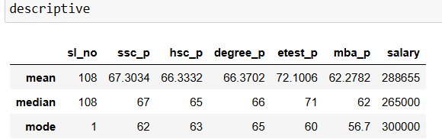

Observation:

The mean , median values of SSC,HSC, Degree and mba marks ranges between 60 to 67 which shows that the performance of overall class is above average.

The mean and median values of entrance test is found slightly higher than the SSC,HSC ,degree and mba marks which showed a sign of improvement.

The Mode value ranges between 60 to 65 for ssc, hsc, degree and entrance test which shows a above average performance and a average performance with 56.7.

The average salary received by this class is 2,88,655 and the repeated salary is 3,00,000 rupees